A

Micro Project Report on

“Online Bazaar UMANG 2K21”

### Submitted by: -

**PRAGATI ARAJ(25)**

*For the Partial Fulfilment of the Requirement for the Sixth Semester Diploma in Mechanical Engineering.*

### Under the guidance of

**M. S. DESHPANDE**

(Lect. Mechanical Engineering Dept.)

**SUBJECT: ENTREPRENEURSHIP DEVELOMENT**



GOVERNMENT POLYTECHNIC THANE PHADKEPADA, OPP. BHARAT GEARS LTD. MUMBRA-SHIL PHATA ROAD, THANE-400612

2020-2021

**MAHARASTRA STATE**

**BOARD OF TECHNICAL EDUCATION**

CERTIFICATE



### This is to certify that the micro project report entitled “Online Bazaar UMANG 2K21”is a benefited work of Pragati Prakash Araj (25) Submitted to the Maharashtra State Board of Technical Education, Mumbai. For partial fulfillment of the requirement for the award of ‘Sixth Semester Diploma in Mechanical Engineering, Subject: **ENTREPRENEURSHIP DEVELOPMENT** during the academic year 2020-2021.

Place: - Diva

Date: -………………………

SUBJECT TEACHER HEAD OF DEPARTMENT PRINCIPAL

**ACKNOWLEDGEMENT**

I avail this opportunity to express my deep sense of gratitude and whole hearted thanks to my guide **Prof. M. S. DESHPANDE** for giving their valuable guidance, inspiration and affectionate encouragement to embark this project report.

I also acknowledge my overwhelming gratitude and immense respect to **Prof. SURESH D SANAP (H.O.D Mech. Eng. Dept.)** and sincere thanks to **Dr. N. N. MHALA (Principal)** who inspired me for completing my project work.

Last but not the least, I would like to thank my beloved parents and my friends who helped me directly or indirectly in my endeavor and infused their help for the success of this work.

- **PRAGATI ARAJ**

**(ME-6-I, 2nd SHIFT)**

**Annexure –I**

**Part – A Micro-Project**

**Title of Micro-Project:** Prakash Papad

**MICRO PROJECT PROPOSAL**

**THE UMAG 2K21**

### AIM BENEFITS OF THE MICRO PROJECT

As per the curriculum requirements of 6th semester entrepreneurship development subject, it’s necessary for every student to prepare business ideas, plans and thereby legitimate it in order to climb the first step of becoming an entrepreneur.

This event will help by:

* + - Develop business ideas and imagination power.
    - Providing face to face marketing events.
    - Increasing confidence level about our idea and decision.
    - Increasing general potential of students.
    - Develop the people convincing skill
    - Making effective advertising of the products.
    - Got knowledge about business planning stages.
    - Helping the students to realize their level in marketing field.
    - Targeting audience’s results in direct sales opportunities.

### COURSE OUTCOMES ADDRESSED

* + - To identify our entrepreneurial traits.
    - To identify the business opportunities in us.
    - To develop comprehensive business plans.
    - To prepare the plans to manage the enterprise effectively.

### PROPOSED METHODOLOGY

#### LIST OF ACTIVITIES REQUIRED FOR ORGANISING THE EVENT:

1. Taking online meeting (Because covid-19 situation) of all student and subject teacher for planning event.
2. Taking review of students about planning online event
3. Write latter to Principle and Head of Department for taking permission for event
4. Selecting online platform for event, there students can sell our product
5. Making team of student for different type of shop
6. Making list of student’s selling product on shop
7. Creating committees for proper organize event
8. Making invitation card, pamphlets for advertising and promotions of event and products.
9. Decide Date of event
10. Creating Proper action plan of online event
11. Creating online link for live selling product on event.
12. Link provided to all students and principle, HOD and all staff
13. Inviting the chief guests, HODS and other staff members.
14. Attain the chief guests, hods and other staff members.
15. Assure proper functioning of the events.

* THE EVENT WILL BE MANAGED WITH THE HELP OF 2 COMMITTE NAMELY:

1. THE EVENT MANAGEMENT COMMITTEE

Functions:

* The event management committee will plan the overall function including budget planning, layout planning, event planning, advertising, etc.
* It also includes giving directions to the event management group.
* Their functions also include deciding the number of stalls required, registration of stalls, assuring equal division of stalls in terms of quantity between first and second shift members.

1. TECHNICAL COMMITTEE

Functions:

* The technical committee plan the all technical service for event like lighting, advertising on online platform, mike, sound system.
* Technical committee help to management committee for solving all technical problem which is facing in event.
* Originating, coordinating, and supervising technical issues.

1. FACTORS THAT HAVE BEEN KEPT IN MIND WHILE DECIDING THE BUDGET

LIST OF THINGS THAT REQUIRE EXPENDITURE:

* Invitation cards
* Advertisement templet
* **LAYOUT OF THE EVENT:**

**DAY 1(27-05-2021)**

|  |  |  |
| --- | --- | --- |
| SHOP NO | SHOP NAME | SHIFT |
| 1 | Assal Malvani Kajugar | 1 |
| 2 | Shivbaba Cooler Services & Handmade Chocolate | 1 |
| 3 | Liaba Collection | 2 |
| 4 | The MIVI Store | 1 |
| 5 | Fine Arts Gallery | 2 |
| 6 | Prakash Papad | 2 |
| 7 | Infinity Petro Chem | 2 |
| 8 | Quality Kishmish | 1 |
| 9 | Vandhan Enterprise | 1 |
| 10 | The Bike Mania | 2 |
| 11 | MR Water Purifier | 2 |
| 12 | Mr. Vinayak & RC Creations | 2 |
| 13 | Perfume Solution | 1 |
| 14 | Just Stationary Thing | 1 |
| 15 | AA Collection | 2 |

**DAY 2(28-05-2021)**

|  |  |  |
| --- | --- | --- |
| SHOP NO | SHOP NAME | SHIFT |
|  |  |  |
| 1 | Friends Collection | 2 |
| 2 | Injection Plastic Mould | 1 |
| 3 | Royal Milk Agency | 2 |
| 4 | Red Onions & Potatos (Kanda Batata) | 1 |
| 5 | InBlue Zone | 2 |
| 6 | Akash Papad | 1 |
| 7 | Label M Fashion Center | 2 |
| 8 | Vikesh Art Gallery | 1 |
| 9 | Abstract Worx | 2 |
| 10 | Personilzed Gift House | 1 |
| 11 | Desi Ghee | 2 |
| 12 | Bike TuneUP Services | 1 |
| 13 | Brands Hub | 2 |
| 14 | Herbal Neen Powder | 1 |
| 15 | The Shoe Box | 2 |
| 16 | Mango Valley | 1 |
| 17 | Star Electronics | 2 |
| 18 | Notorious | 1 |
| 19 | Cake & Pastrey | 1 |
| 20 | All Vegetables | 1 |
| 21 | Silver Coated & Plates | 1 |
| 22 | Selling Auto Spare Part | 1 |
| 23 | Assam Tea | 1 |
| 24 | Hachery Fish Seed | 1 |
| 25 | Kamla Enterprises | 2 |
| 26 | The Pulse Shopee | 2 |

### ACTION PLAN

|  |  |  |  |
| --- | --- | --- | --- |
| **SR NO** | **DETAILS OF ACTIVITY** | **PLANNED START DATE** | **PLANNED FINISHED DATE** |
| 1 | To find the topic of Project | 25/03/2021 | 27/03/2021 |
| 2 | Topic Name: Prakash Papad | 29/03/2021 | 03/04/2021 |
| 3 | discussion on project | 05/04/2021 | 10/04/2021 |
| 4 | To find out literature from book | 12/04/2021 | 17/04/2021 |
| 5 | To collect information from internet | 19/04/2021 | 24/04/2021 |
| 6 | Discussion on collected information | 26/04/2021 | 01/05/2021 |
| 7 | Distribution of work to team members | 03/05/2021 | 08/05/2021 |
| 8 | Compiling of information | 10/05/2021 | 15/05/2021 |
| 9 | Compiling of information | 17/05/2021 | 22/05/2021 |
| 10 | Formation of Project ppt | 24/05/2021 | 29/05/2021 |
| 11 | Presentation & Submission | 31/05/2021 | 05/06/2021 |
| 12 | Presentation & Submission | 07/06/2021 | 12/06/2021 |

* **SCHEDULE OF THE EVENTS:**

|  |  |  |  |
| --- | --- | --- | --- |
| **Sr no.** | **Day 1**  **Time** | **Day 2**  **Time** | **DESIRED EVENTUALITIES** |
| 1 | 1.00 PM | 11 AM | Reporting time of all stall member to the google meeting |
| 2 | 1.15 PM | 11.15 AM | Google Meet link created by Technical Team will be shared to participants Student |
| 3 | 1.30 PM | 11.30 AM | Technical Team will admit the participants |
| 4 | 1.31 PM | 11.31 AM | Event Banner will be Displayed on the Screen until event starts. |
| 5 | 1.32 PM | 11:32 AM | Host will call out TUSHAL SANGOLIKAR (Event Manager) for Introduction Speech |
| 6 | 1.40 PM | 11:40  AM | HOD - SANAP SIR to give speech on Entrepreneurship |
| 7 | 1.55 PM | 11:55 AM | PRINCIPAL - MHALA SIR to Inaugurate the Function and Give  Speech on Entrepreneurship |
| 8 | 2.05 PM | 12.05 PM | EXPERT Guest to Give Speech on their Experience & Entrepreneurship |
| 9 | 2.15 PM | 12:15 PM | Host will tell the instructions regarding the purchase of products and order placing |
| 10 | 2.20 PM  To  4.00 PM | 12:20 PM  To  4.05 PM | Start of the Stall Presentation   * (Solo Product Presentation Maximum - 5 mins Including Video + Intro + Outro = 5 mins) * (Group Product Presentation Maximum - 8 mins Including Video + Intro + Outro = 8 mins) |
| 11 | 4.00 PM | 4.05 PM | Thank you speech |
| 13 | 4.05 PM | 4:10PM | End of the event |

* **Event Schedule** –

**[SECTION - I]**

1. All Event Management Committee Members Will Start the Meeting 30 Mins before the Start of Event. Committee will check working of Network, YouTube Live, Facebook Live and Screen Sharing testing.
2. Google Meet link created by Technical Team will be shared to participants 15 mins before start of the Event.
3. Technical Team will admit the participants in 15 mins.
4. Event Banner will be Displayed on the Screen until event starts.
5. After Start of the Event, Host will call out TUSHAL SANGOLIKAR (Event Manager) for Introduction Speech - 2 to 3 Mins
6. After Introduction Speech, Host will call out HOD - SANAP SIR to give speech on Entrepreneurship - 5 to 8 mins.
7. After HOD speech, Host will call out PRINCIPAL - MHALA SIR to Inaugurate the Function and give Speech on Entrepreneurship - 7 to 10 mins.
8. After PRINCIPAL SPEECH, Host will call out EXPERT to Give Speech on their Experience & Entrepreneurship - 10 mins.

[SECTION - II]

1. Host will tell the instructions regarding the purchase of products and order placing - 5 mins.

B) Start of the Stall Presentation -

(Solo Product Presentation Maximum - 5 mins Including Video + Intro + Outro = 5 mins)

(Group Product Presentation Maximum - 8 mins Including Video + Intro + Outro = 8 mins)

UMANG 2k21

* COMMITTEE MEMBERS

1. Management Committee

* Rupesh Choudhari
* Tushal Sangolikar
* Vinay Marathe
* Aaman Momin
* Mansi Rathod

1. Technical Committee

* Kaustubh Patil
* Gaurav Bangar
* Chinmay Sanap
* Aniruddha Wagh,
* Shivanand Jagave

1. Invitation Committee

* Suyog Surve,
* Kajal Mishra,
* Chakresh Kanekar

1. Event Incharge

* Tushal Sangolikar (1st Shift)
* Rupesh Choudhari (2nd Shift)

1. Event Host

* Vinay Marathe,
* Rupesh Choudhari.

### RESOURCES REQUIRED

**FOR DECORATIONS:**

* Invitation card for principle and staff members.
* Banner that contains information about event
* Banner for welcoming the chief guests.

**FOR STALLS:**

* Advertisement template
* Google meeting

**FOR INDIVIDUAL STALL MEMBERS:**

* Pamphlet and PPT for giving production information.
* Banner of the stall
* Marketing skills for selling the product
* Shipping service available

### NAME OF THE TEAM MEMBERS WITH ROLL NUMBERS

1. Pragati Prakash Araj (25): 1815700096

**Annexure –II**

**Part – B Micro-Project**

**THE UMANG 2K21**

**Title of Micro-Project:** Prakash Papad

* 1. RATIONALE

As per the curriculum requirements of 6th semester entrepreneurship development subject, it’s necessary for every student to prepare business ideas, plans and thereby legitimate it in order to climb the first step of becoming an entrepreneur. Entrepreneurship is important as it has the ability to improve standards of living and create wealth, not only for the entrepreneurs, but also for related businesses. Entrepreneurs also help drive change with innovation, where new and improved products enable new markets to be developed. The importance of entrepreneurship in a country and its economic growth is remarkable.

### 2.0 AIM BENEFITS OF THE MICROPROJECT

* + - Improved communication skills required for marketing
    - Learned about presentation of products and plan.
    - Increased confidence level while communicating.
    - Helped to establish consumer-retailer relationship.
    - Learned about organization of an event.
    - Got a basic idea about work culture.
    - Helped in overall personality development.
    - Teamwork
    - Analytical and critical thinking
    - Helped in monitoring and effectively manage monetary resources

### 3.0 COURSE OUTCOMES ACHEIEVED

* + - Identified our entrepreneurial traits.
    - Identified the business opportunities in us.
    - Developed comprehensive business plans.
    - Prepared the plans to manage the enterprise effectively.
    - Used support system t zero down for business ideas

### LITERATURE REVIEW

Many researchers differentiated entrepreneur from entrepreneurship process so as to understand entrepreneurship well. Cunningham & Lis heron, (1991) focused on the need of understanding entrepreneurship effectively. The majority of entrepreneurship studies revealed that there are four major dimensions, which influence the development of entrepreneurship vitally (Jain, 2011)

* + 1. individual,
    2. socio-culture tradition,
    3. support system and
    4. Environment.

The entrepreneurs (an individual) and entrepreneurship (processes undertaken by entrepreneurs or supporting activities around them) are analogues to the entrepreneurial development process. Hence for the purpose of present study based on studies, classified as individual based or entrepreneurial processes and or on support activities has been done.

**Emerging themes in Indian Studies**

The Indian research on entrepreneurs have also seen various areas of research that includes women entrepreneurship (Goal & Prakash, 2011), entrepreneurs from minority (Barr, 2008), public entrepreneurs, ethnic entrepreneurs, Indian entrepreneurs working abroad (Nanda & Khanna, 2009). The majority of these research focused on constraints that entrepreneurs from each strata has faced in the process of their developments and steps taken by them to overcome their challenge have focused on prior entrepreneurship expenditures, size of industrial business networks, support received from families were found to be significant while education, parental ownership of business, network competitive characteristics, relative to kinship were non-significant in nature growth.

**Conclusion and Future Studies**

**Based on the above studies, it was found that:**

* + - Entrepreneurship in India has originated from the realms of *Sanatana* Dharma (*Vaisya* Verna) and has grown beyond boundaries of *Sanatana*. It was found that entrepreneurial drive was found to have connections with religion and Dharma. However, over a period, it has gone beyond the realms and individuals were driven to entrepreneurial endeavours on account of their needs rather than religion.
    - The Indian researchers have not discussed many entrepreneurs and entrepreneurship, the most of the non-Indian researchers have thrown light mostly on the concept of entrepreneurship.
    - The major attributes among entrepreneurs observed were found to be mix of skills and traits, whereas researchers like Carland et. al. (1988) concluded that the character traits of an entrepreneur are important in entrepreneurial decision making approaches. Gartner (1988) on the other hand criticized this claim and stated that the advances in understanding entrepreneurial behaviour can come from focusing on entrepreneurial processes rather than the personality traits.
    - Certain studies posit that the individuals exhibit exceptional entrepreneurial drive and spirit when they operate in the new environment. Entrepreneurial skills of innovation, creativity, risk taking, venture creating, capacity to dynamically handle economic systems, management of resources, projective and visionary thinking, focus on action or strong desire, leadership, control, opportunity recognition and ability to convert threats into opportunities, change management, attitude of being rebel and delinquent possibly leads to better entrepreneurial development.

**A review of the literature revealed that**

* + - Researchers have posited entrepreneurship as an ability and trait. The obvious debate was observed in the review of literature. To determine which factors affect most, future studies require specific modeling and investigation. We have proposed broad based on our findings that affect entrepreneurial development. This model serves the purpose of choosing antecedents broadly for our future studies. Specific models may require further investigation of variables.
    - Entrepreneur's personality traits, their passion, socio-cognition, innovation, culture, family background, etc. These factors associated with EO plays a vital role in initiating, promoting, and nurturing entrepreneurship which is termed as culture, customs, traditions, family background, education and socio-political environments.
    - Certain studies revealed that the entrepreneurship is not always by way of orientation or autonomous personality traits, internal locus of control and need for autonomy. These studies accountably consider entrepreneurial abilities as antecedents.
    - Poverty and or dissatisfaction (Bouchard, and Basso, 2011) with existing employment pushes individual into entrepreneurship.
    - Certain studies posit a demand for a need of studying network of culture, individual traits and entrepreneurship is to be studied with respect to his/her cultural dimensions or aggressiveness with or mix dynamics prevailed in the society
    - Most of the studies have been done in developed in the context of countries like USA, Europe and few economically evolving countries like Japan & China. A few entrepreneurial comparative studies with Asian countries have been undertaken with Indonesia, Korea, etc. India is having most diversified culture in terms of religion, community, languages and demography. Several authors have posited the demand to make meanings from Indian studies in the area of entrepreneurship. It was observed that there are several factors that affect the development of entrepreneurship and establishes several entrepreneurial traits and represent the basis for entrepreneurship development.

Human interrelations are very complex in nature. Individual’s decision varies in different situations and environments. Therefore, to develop a broader theoretical and practical agenda by considering additional variables, related to the industry and its financial involvement and the culture in which it operates can yield more information on impacts of these exogenous factors on entrepreneurial orientations, evolving entrepreneurial leadership styles, marketing or business operating styles. Given the case, it was found that entrepreneurial development (ED) is moderated by various exogenous factors viz. education and government support (as may be in the case of MSME, conducive policies for business promotions etc.).

5.0 ACTUAL METHODOLOGY FOLLOWED

REPORT OF THE EVENT

Their first ever entrepreneur’s funfair entitled as THE UMANG 2K21 organized by entrepreneurs of Mechanical Department on 27 May and 28 May 2021. This event organized at online platform like google meeting and YouTube.

All Event Management Committee Members Started the Meeting 30 Min before the Start of Event. Google Meet link created by Technical Team shared to participants before start of the Event. All participants joint the event on google meeting link. After the event banner displayed on the Screen until event starts. Technical committee shared this online event live on the YouTube. After Start of the Event, Host called out TUSHAL SANGOLIKAR (Event Manager) for Introduction Speech and also gave the welcome speech. After Introduction Speech, Host called out HOD - SANAP SIR to give speech on Entrepreneurship. Than HOD speech, Host called out PRINCIPAL - MHALA SIR to Inaugurate the Function and give Speech on Entrepreneurship. After PRINCIPAL SPEECH, Rupesh introduced our expert guest, after that EXPERT gave Speech on their Experience & Entrepreneurship.

Later, Host told the instructions regarding the purchase of products and order placing. Host called one by one stall number and then stall member started their presentation as per calling. After completed all presentation teacher gave her reaction and comments on this event. Later host gave thank you speech and end of event. the event got great success and well organized.

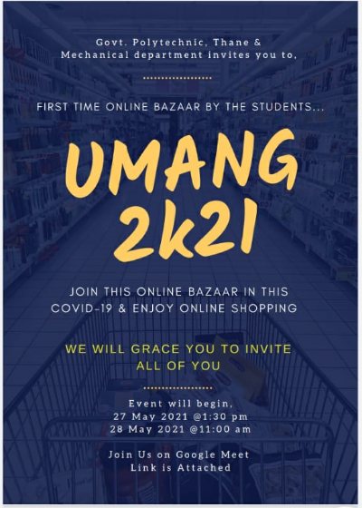

UMANG 2k21

* COMMITTEE MEMBERS

1. Management Committee

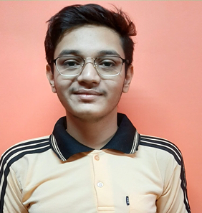 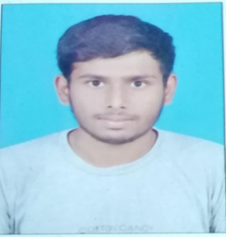 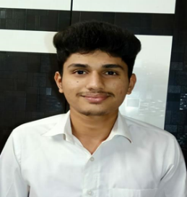 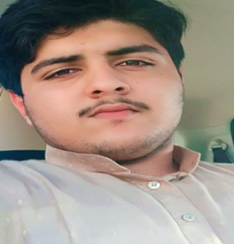

Rupesh Choudhari Tushal Sangolikar Vinay Marathe Amaan Momin

1. Technical Committee

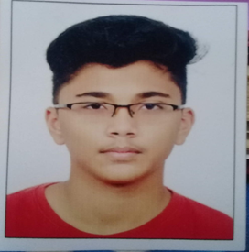 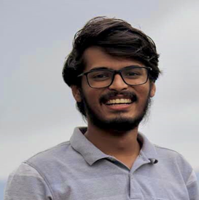 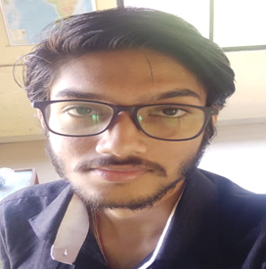 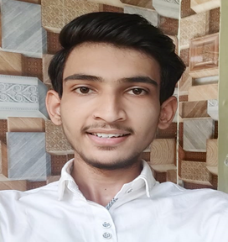

Kaustubh Patil Gaurav Bangar Chinmay Sanap Aniruddha Wagh

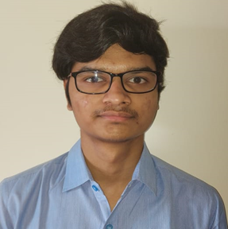 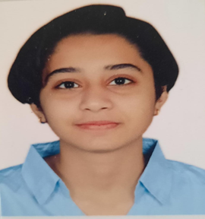

Shivanand Jagave (ME4I) Mansi Rathod (ME4I)

1. Invitation Committee

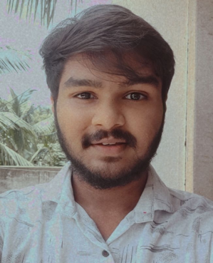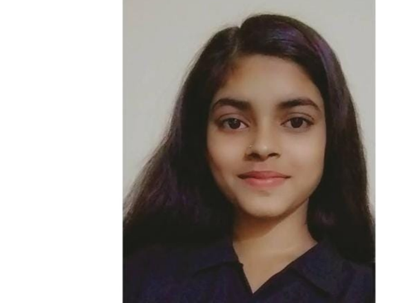 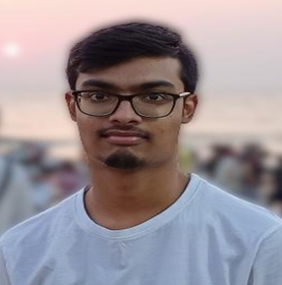

Suyog Surve Kajal Mishra (ME4I) Chakresh Kanekar (ME4I)

1. Event Incharge

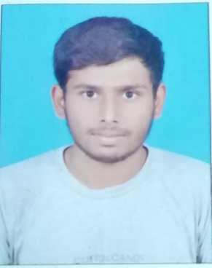 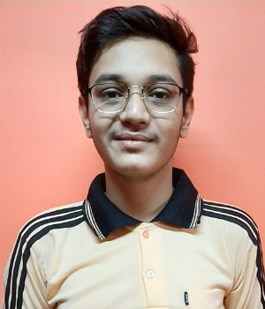

Tushal Sangolikar (1st Shift) Rupesh Choudhari (2nd Shift)

1. Event Host

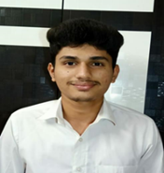 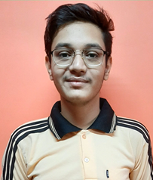

Vinay Marathe Rupesh Choudhari.

**GOVERNMENT POLYTECHNIC, THANE**

PHADKE POAD, OPPOSITE BHARAT GEARS, PHADKEPADA, MUMBRA, THANE-400612

DATE: 21st MAY, 2021

To,

The Principal,

Government Polytechnic Thane, Phadkepada, Thane-400612.

**SUBJECT: PERMISSION FOR ORGANISING THE EVENT ‘UMANG 2K21’**

**(online web bazar conducted through webinar)**

Respected Sir,

As per the syllabus requirements of the **SUBJECT: ENTREPRENEURSHIP DEVELOPMENT (22032)**, we are required to organize a marketing event which will act as a source to organize a virtual face to face marketing event for us in the form of web-bazar.

Thus, we have come up with the proposal of organizing the event named **‘UMANG 2K21 - A PLACE FOR BUDDING ENTREPRENEURS’.** The event includes preparation of stalls to sell various products by the students of Mechanical Engineering Department 3rd Year taken **by online-mode through web- bazar**. Students will give presentation and demonstrate their product in the webinar. All staff members and students will join the online meeting. Various products will be sold in the online bazar. The purpose and the outcomes of the events are-

* Increase general potential of the students in marketing.
* To provide a virtual face-to-face marketing event.
* To help students to recognize their potential in marketing field.
* To create lasting impressions and a base idea for the juniors to carry out similar activities in future.

We have approximately decided the date of holding this event on **27th MAY 2021** but it will be changed as per convenience and based on lockdown. Since, it would not possible to conduct the event in a single meeting on one day, hence the event will be presented on 2 consecutive days **27th & 28th MAY, 2021.** The entire event will be organized by the expenses and guidance of the students. We also thereby assure you that this event will be planned, managed and executed decently and will be a great success.

Thus, we desire a positive reply from your side in terms of permission for this online bazar.

Thanking you in anticipation,

**HOD (MECAHNICAL) ENCOURAGED BY- REGARDS,**

Prof. S.D. SANAP Mrs. M.S. DESPANDE TUSHAL SANGOLIKAR (ME-6I First shift)

RUPESH CHAUDARI (ME-6I Second shift)

* **INVITATION CARDS**

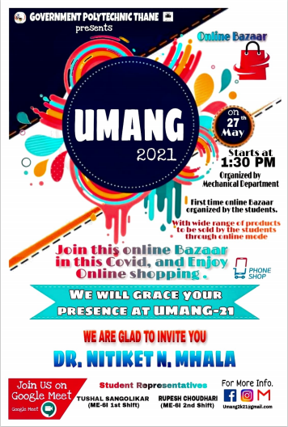

* **CHIEF GUEST (EXPERT SPEAKER):**
* Day 1 (27 May 2021): Anant. M. Shinde

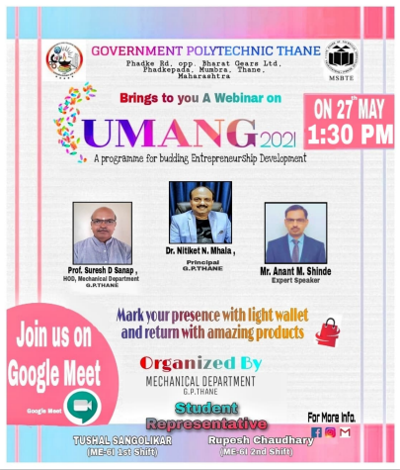

* Day 2 (28 May 2021): Swapnil Karwade

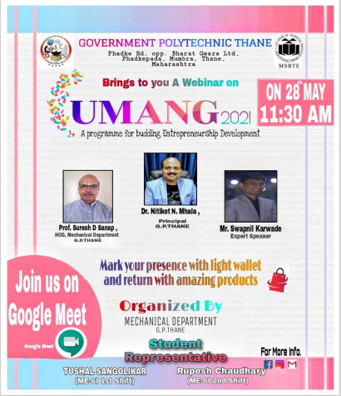

* GOOGLE MEET LINK FOR EVENT:
* **Day 1: 27 May 2021**

 UMANG 2k21 

GOVERNMENT POLYTECHNIC,THANE & STUDENTS OF MECHANICAL DEPARTMENT⚙️ INVITES YOU TO

FIRST TIME ONLINE BAZAAR ORGANISED BY THE THIRD YEAR MECHANICAL STUDENTS

🛒 JOIN OUR ONLINE BAZAAR IN THIS COVID-19 & ENJOY ONLINE SHOPPING

JOIN US ON GOOGLE MEET ON 27 MAY THURSDAY AT 1:30 PM

 Google Meet Joining Link -_

https://meet.google.com/zah-ijwx-rfh

Mark Your Presence With Some Light Wallet  & Encourage Our Students 

* **Day 1: 27 May 2021**

UMANG 2k21 

GOVERNMENT POLYTECHNIC,THANE & STUDENTS OF MECHANICAL DEPARTMENT⚙️ INVITES YOU TO

FIRST TIME ONLINE BAZAAR ORGANISED BY THE THIRD YEAR MECHANICAL STUDENTS

🛒 JOIN OUR ONLINE BAZAAR IN THIS COVID-19 & ENJOY ONLINE SHOPPING

JOIN US ON GOOGLE MEET ON 28 MAY THURSDAY AT 11:30 PM

Google Meet Joining Link -_

https://meet.google.com/zah-ijwx-rfh

Mark Your Presence With Some Light Wallet  & Encourage Our Students 

UMANG 2K21

**Day 1: 1st Webinar (27-05-2021)**

* INTRODUCTION OF UMANG

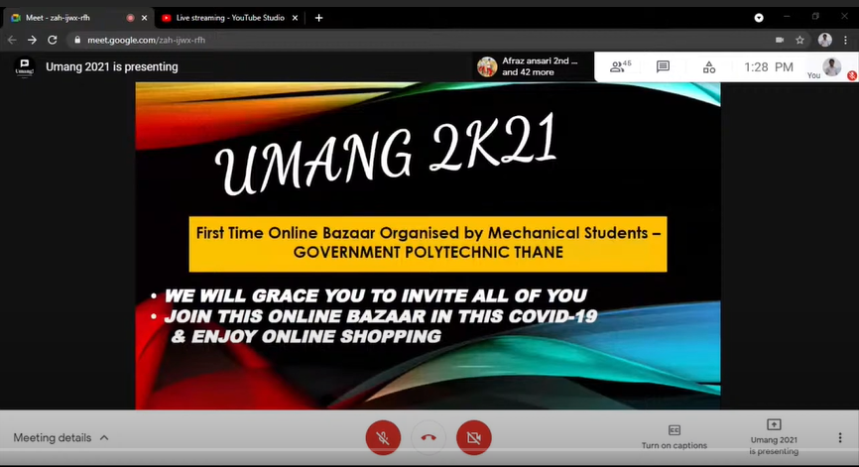

* **SPEECH BY PRINCIPLE: DR.N.N. MHALA**

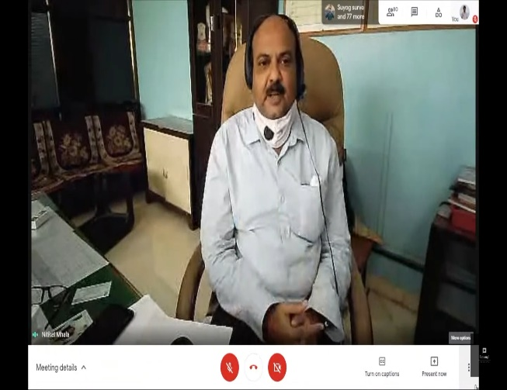

* **SPEECH BY HOD: S. D. SANAP**

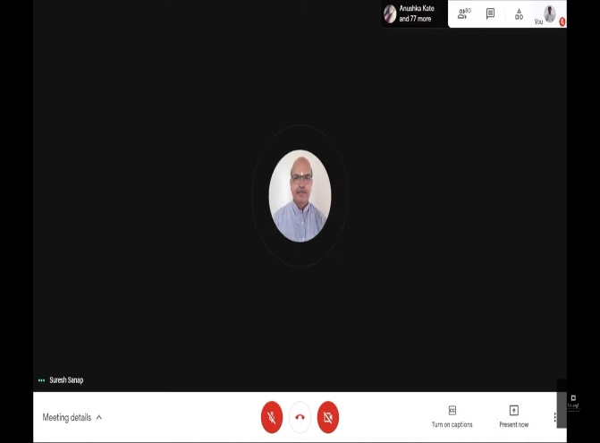

* **EXPERT SPEAKER: MR. ANANT M. SHINDE**

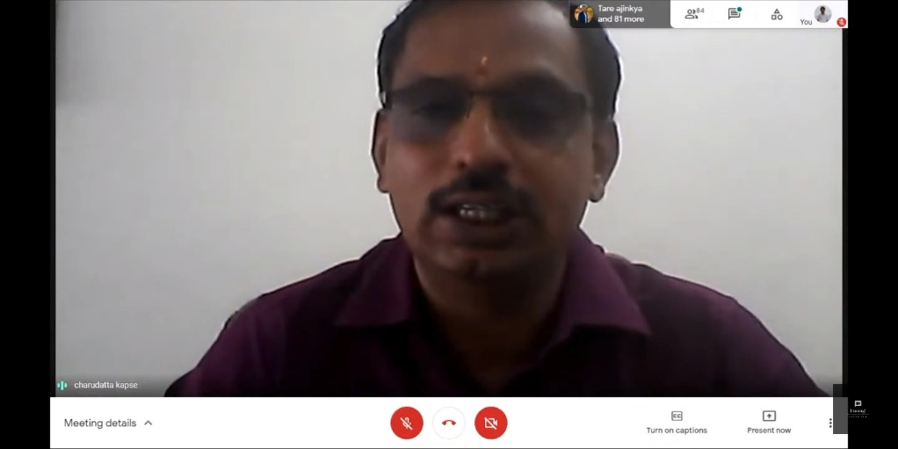

* **GUIDANCE BY DESHPANDE MAM**

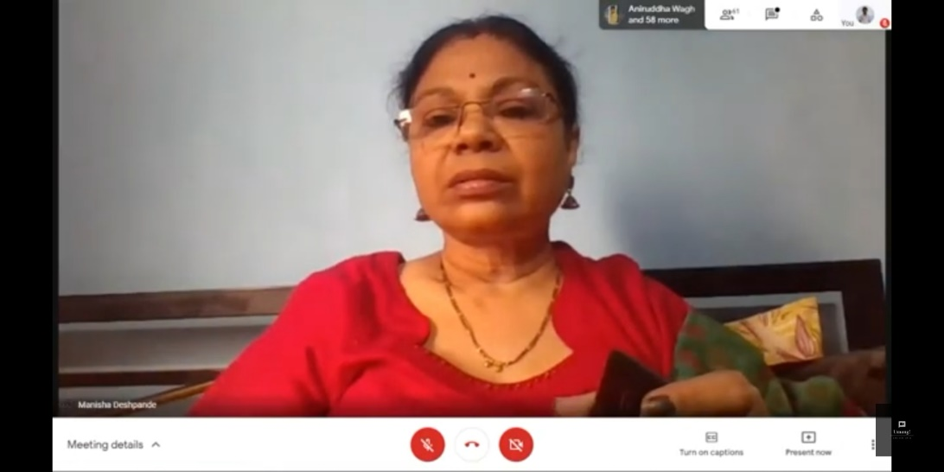

* **HOST: VINAY MARATHE AND RUPESH CHOUDHARI**

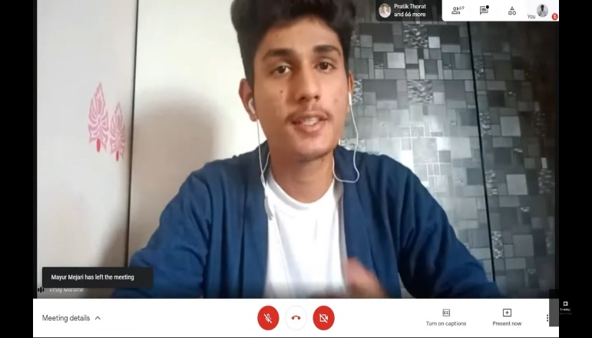 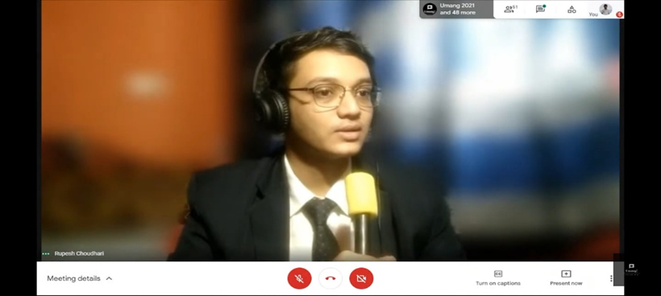

* **PRESENTATION ON SELLING PRODUCT BY STUDENTS:**

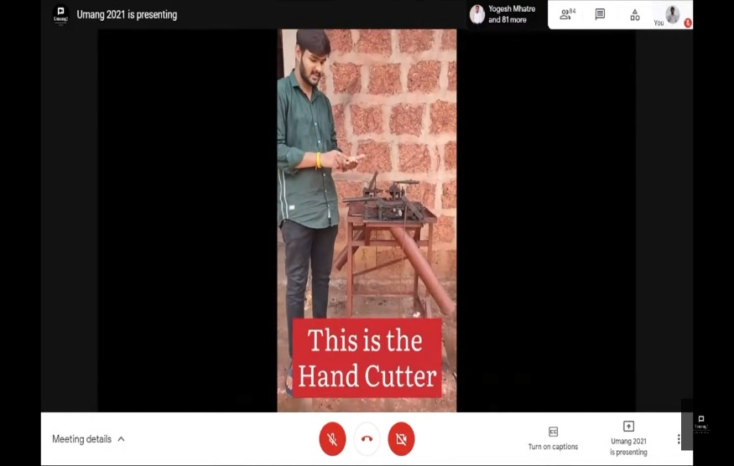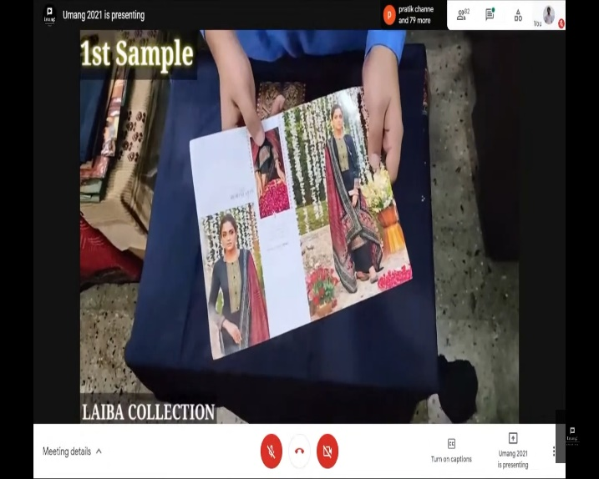

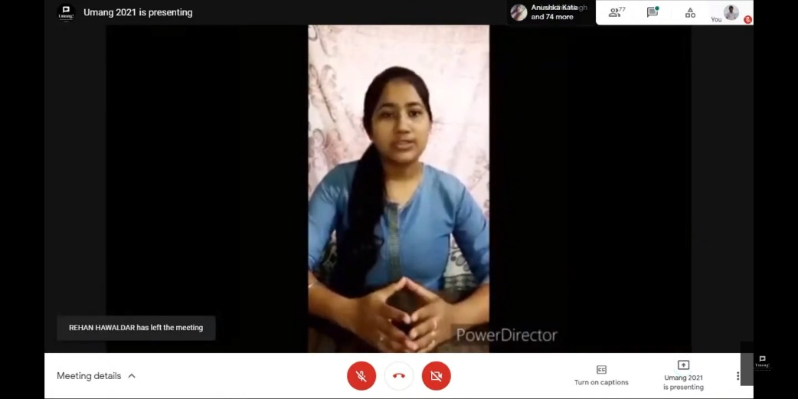

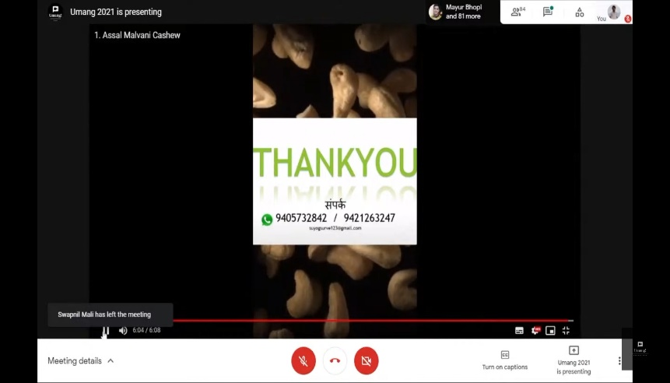

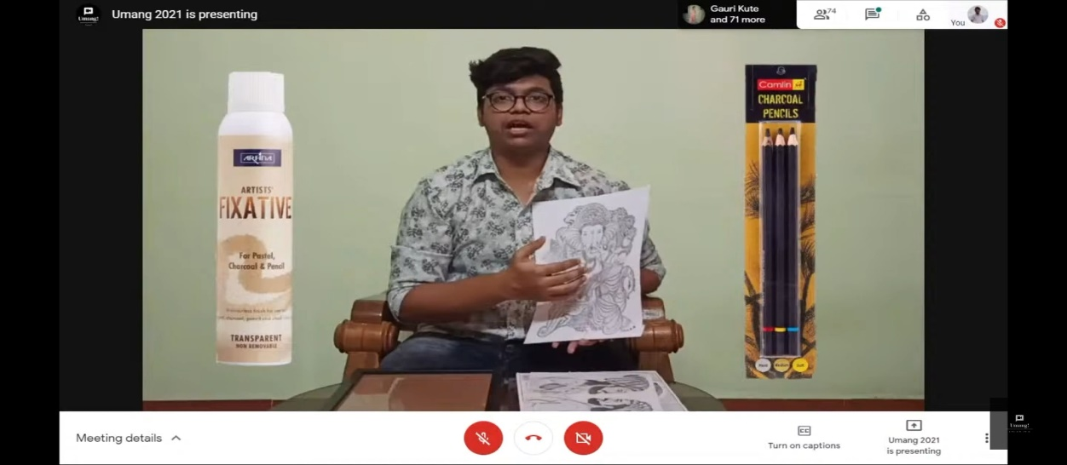

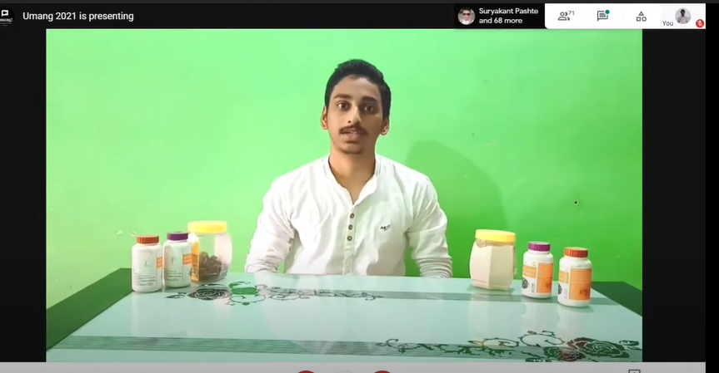

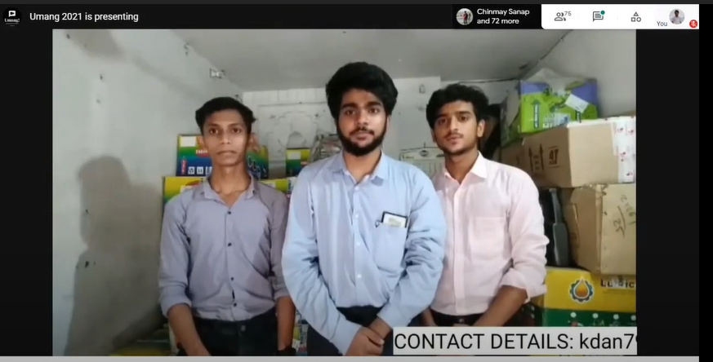

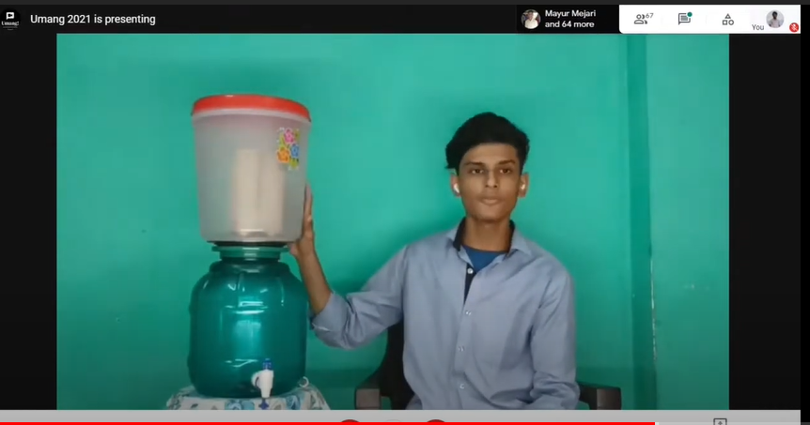

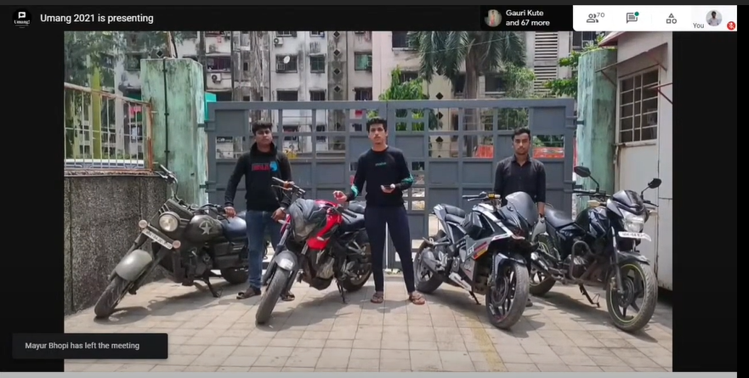

**Day 2: 2nd Webinar (28-05-2021)**

* **INTRODUCTION OF UMANG**



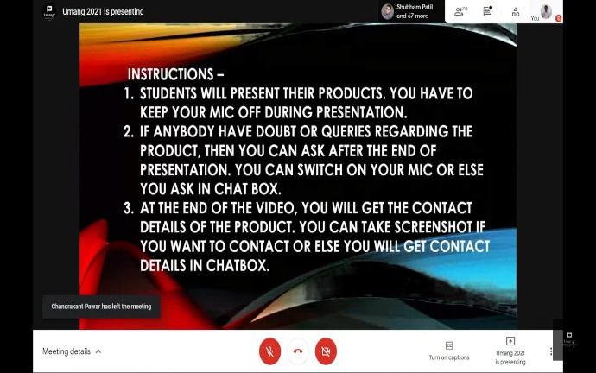

* **SPEECH BY K. V. PATIL SIR**

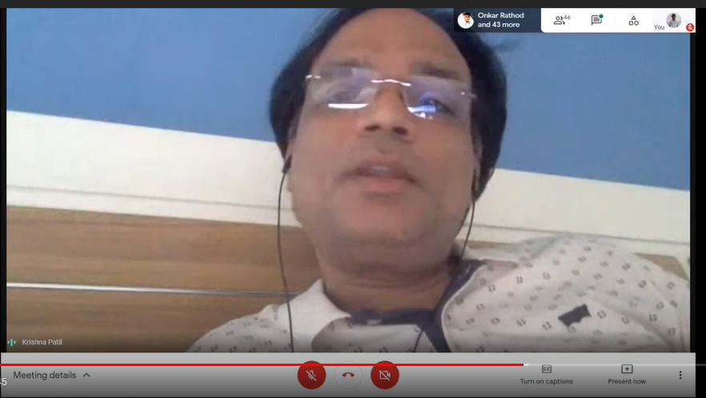

* **EXPERT SPEAKER: MR. ANANT M. SHINDE**

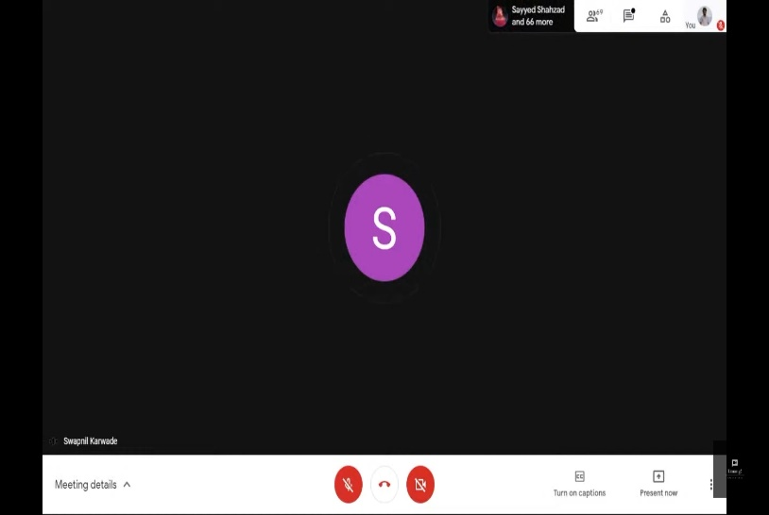

* **HOST: VINAY MARATHE AND RUPESH CHOUDHARI**

** **

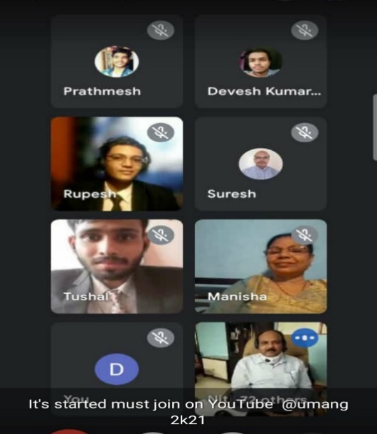

* **PRESENTATION ON SELLING PRODUCT BY STUDENTS:**

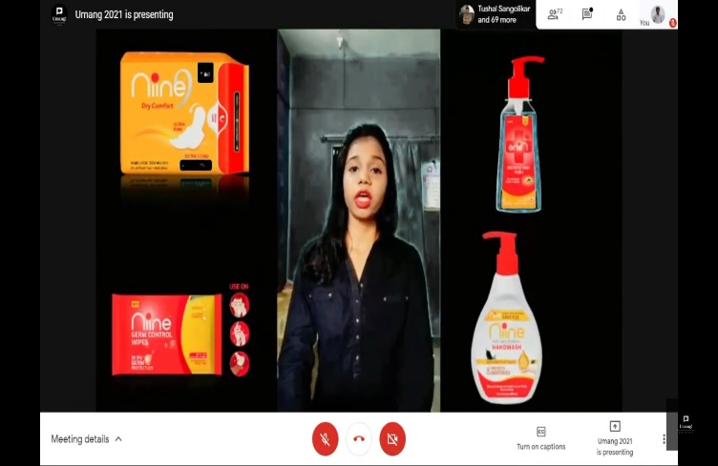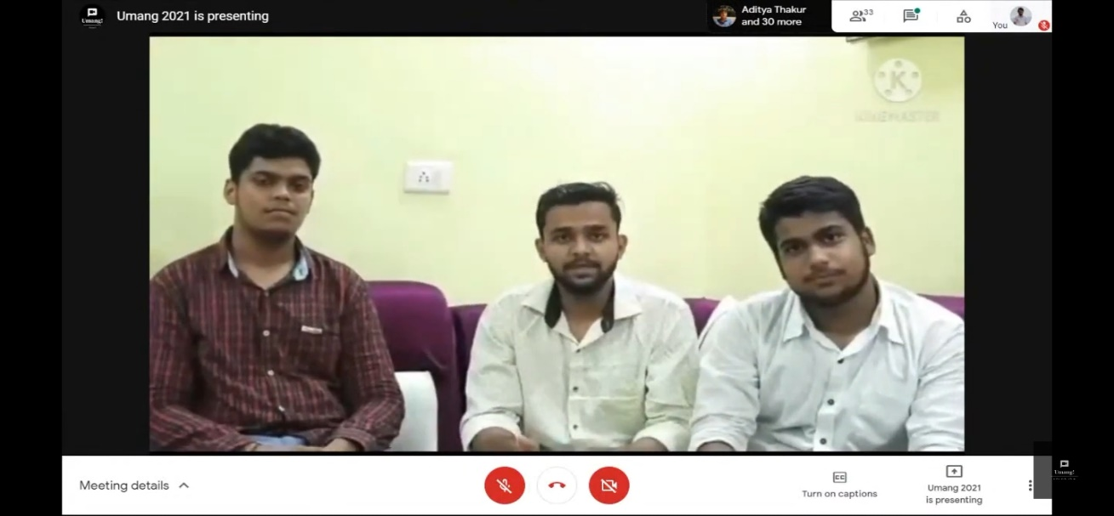

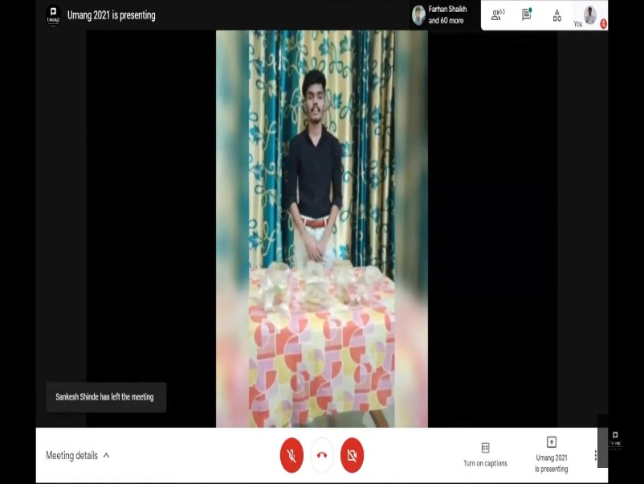

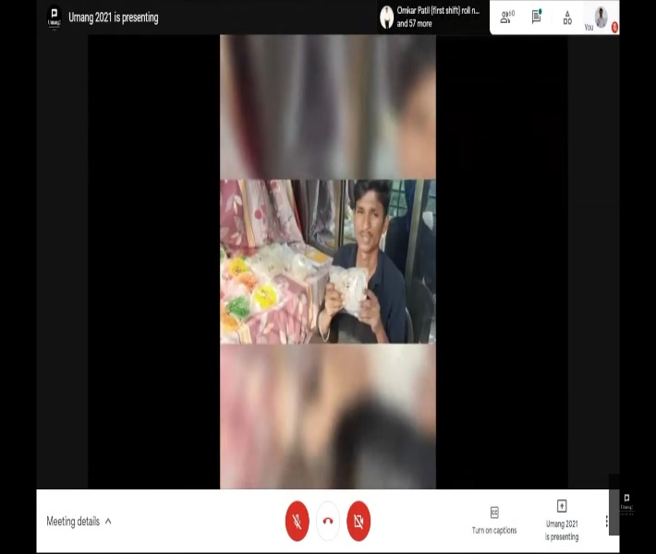

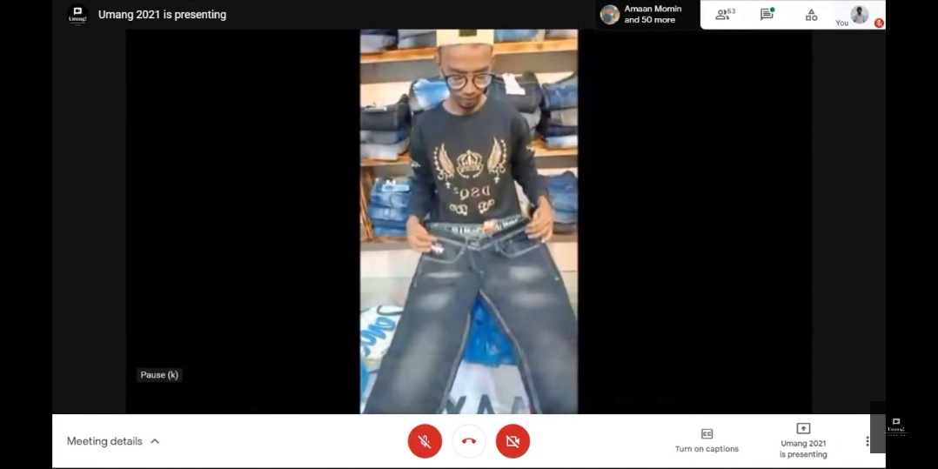

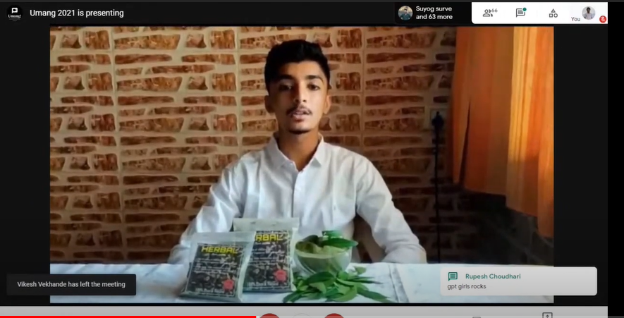

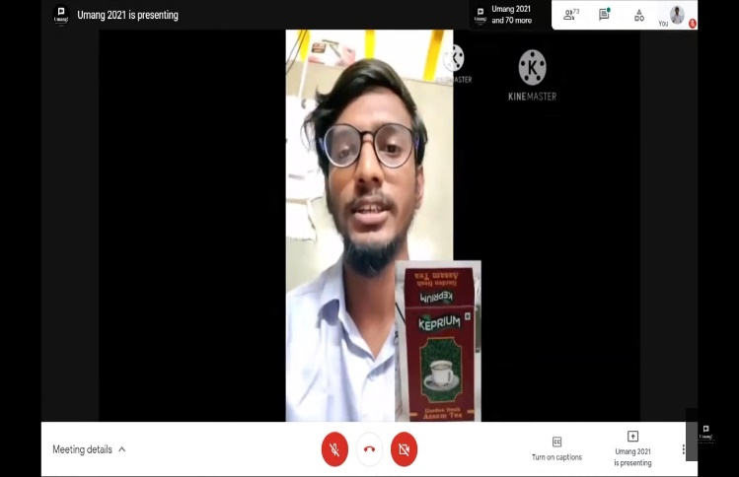

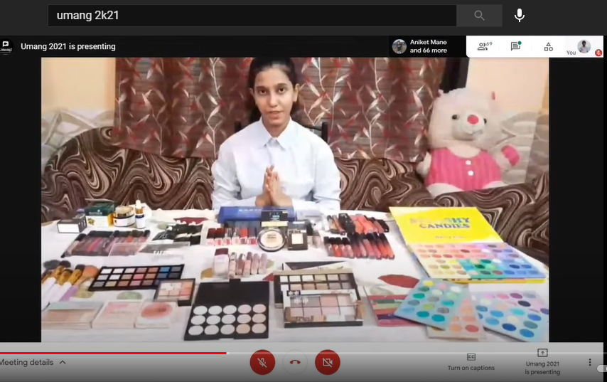

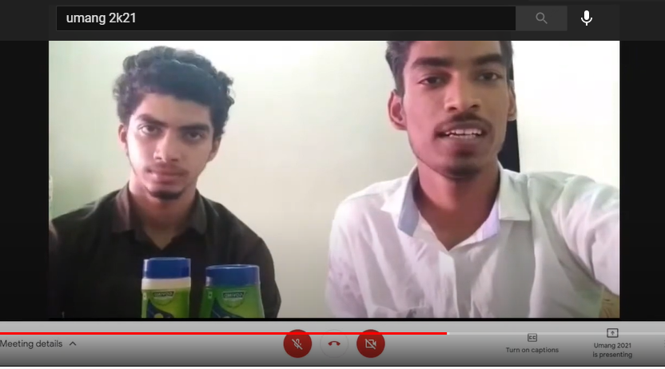

* **SCHEDULE OF THE EVENTS:**

|  |  |  |  |
| --- | --- | --- | --- |
| **Sr no.** | **Day 1**  **Time** | **Day 2**  **Time** | **DESIRED EVENTUALITIES** |
| 1 | 1.00 PM | 11 AM | Reporting time of all stall member to the google meeting |
| 2 | 1.15 PM | 11.15 AM | Google Meet link created by Technical Team will be shared to participants Student |
| 3 | 1.30 PM | 11.30 AM | Technical Team will admit the participants |
| 4 | 1.31 PM | 11.31 AM | Event Banner will be Displayed on the Screen until event starts. |
| 5 | 1.32 PM | 11:32 AM | Host will call out TUSHAL SANGOLIKAR (Event Manager) for Introduction Speech |
| 6 | 1.40 PM | 11:40  AM | HOD - SANAP SIR to give speech on Entrepreneurship |
| 7 | 1.55 PM | 11:55 AM | PRINCIPAL - MHALA SIR to Inaugurate the Function and Give  Speech on Entrepreneurship |
| 8 | 2.05 PM | 12.05 PM | EXPERT Guest to Give Speech on their Experience & Entrepreneurship |
| 9 | 2.15 PM | 12:15 PM | Host will tell the instructions regarding the purchase of products and order placing |
| 10 | 2.20 PM  To  4.00 PM | 12:20 PM  To  4.05 PM | Start of the Stall Presentation   * (Solo Product Presentation Maximum - 5 mins Including Video + Intro + Outro = 5 mins) * (Group Product Presentation Maximum - 8 mins Including Video + Intro + Outro = 8 mins) |
| 11 | 4.00 PM | 4.05 PM | Thank you speech |
| 13 | 4.05 PM | 4:10PM | End of the event |

### **ACTUAL** **RESOURCES REQUIRED**

* Invitation card for principle and staff members.
* Banner that contains information about event
* Banner for welcoming the chief guests.
* Advertisement template
* Google meeting

1. **OUTPUTS OF THE MICRO PROJECT**

**REPORT OF PRODUCTS SOLD AND INVESTMENT**

* PRODUCT NAME: Prakash Papad

1. Urad Dal Papad
2. Moong Dal Papad
3. Chawalke Papad
4. Shabudane Papad

* TOTAL INVESTMENT OF BUSINESS:

The total investment of business is Rs 10,000.

* INITIAL INVESTMENT:

|  |  |  |
| --- | --- | --- |
| **SR.NO** | **Liability/Assets** | **Invested** |
| 1 | Raw material | Rs 9000 |
| 2 | Equipment( polipat) | Rs 500 |
| 3 | Grinding machine | Already have |
| 4 | Electric Bill | Rs 500 |
| 5 | Google pay, Bank Account | For receiving payments |

* STRATEGY FOR PROFIT:

|  |  |  |
| --- | --- | --- |
| Service | Price Per Kg | Profit |
| We providing dal for Papad | Rs 250 | Rs 70 |
| You providing dal for Papad | Rs 200 | Rs 50 |

* CUSTOMER LIST:

I have 47 customers for my business so there I am displaying some customer’s details

|  |  |  |  |
| --- | --- | --- | --- |
| **Sr. no.** | **NAME OF THE CUSTOMERS** | **SELLING PRICE** | **PROFIT** |
| **1** | Lata Sadashiv Araj | 750 | 210 |
| **2** | Gita Kashinath Bhoir | 1000 | 350 |
| **3** | Neha Ramesh Kor | 500 | 120 |
| **4** | Aruna Arun Ruat | 1000 | 350 |
| **5** | Sakshi Sandeep Khadge | 250 | 70 |
| **6** | Santosh Dattrate Gonade | 1400 | 490 |
| **7** | Radhika Mohan kashivale | 400 | 120 |
| **8** | Archana Ramdas Athivale | 500 | 140 |
| **9** | Kedar Krushna Ghodvende | 600 | 180 |
| **10** | Chaitana udin sheroshei | 750 | 210 |
| **11** | Sushant Bhushan Mirakuthe | 800 | 240 |
| **12** | Pallavi Alpesh Bhoir | 500 | 140 |

* RETURN OF INVESTMENT

|  |  |  |  |  |  |
| --- | --- | --- | --- | --- | --- |
| **Sr.No** | **Customer No** | **Product Name** | **Selling** | **Income** | **Profit** |
|  |  | Date:21-4-2021 to 10-5-2021 |  |  |  |
| 1 | 10 | Urad Papad | 15kg | 3750 | 1050 |
| 2 | 4 | Chawal Papad | 8kg | 2000 | 600 |
| 3 | 6 | Shabudana Papad | 12kg | 3000 | 840 |
| 4 | 6 | Moong Papad | 7kg | 1750 | 500 |
|  |  | Date: 11-5-2021 to 20-5-2021 |  |  |  |
| 5 | 6 | Chawal papad | 14kg | 3500 | 980 |
| 6 | 3 | Moong papad | 7kg | 1750 | 500 |
| 7 | 7 | Urad papad | 10kg | 2500 | 700 |
| 8 | 5 | Shabudana Papad | 8kg | 2000 | 480 |
|  |  |  |  |  |  |
| **TOTAL** | **47** | **8** | **42kg** | **20,250** | **7250** |

* TOTAL INVESTMENT: 10,000 RS
* OTHER INVESTMENT: 3,000
* TOTAL SELLING: 20,250 Rs
* TOTAL PROFIT MADE: RS 7250
* TOTAL LOSS: 0 RS

8.0 SKILLS DEVELOPED/ LEARNING OUTCOMES OF THE PROJECT

* + INCREASED CONFIDENCE LEVEL WHILE COMMUNICATING

Confidence level give us effective communication skill to representing our self in front of society, business presentation or interview also help to make great impact on people about our behavior, communication style, politeness in language.

Whenever you will communicate with customer about product selling so you must have confidence in your language its help to explain the product policy and convincing to customer. Communication is also important within the business. Effective communication can help to foster a good working relationship between you and your staff, which can in turn improve morale and efficiency.

#### **PUBLICALY SPEAKING SKILL**

Public speaking is a [soft skill](https://www.thebalancecareers.com/what-are-soft-skills-2060852) that requires excellent communication skills, enthusiasm, and the ability to engage with an audience. Public speakers make presentations to a group.

Whenever you are specking in front of audience and office colleagues at meeting or event that you must be clear about your idea and strategy to continuous this webinar or event. If you will be specking in meeting or product selling event that time your presenting style is most important for impactful webinar like your vocal tone, body language, facial expression, and timing.

* **LISTENING**

Listening skill make the simple webinar into the professional webinar. In that people can listening to other people presentation or speech so the speaker can explain their view or idea to you also speaker got confidence and happiness that all audience like their presentation.

When you’re listening to others, pay as much attention to them as you can. Notice quirks in their body language. Listen to their words and, if you have trouble focusing on them, repeat their words in your head to help you retain focus and absorb the information. Avoid interrupting a person you’re listening to, but do show that you’re interested in what they’re saying by responding with short, encouraging comments like, “I see” or “Yes.”

* + **LEARNED ABOUT PRESENTATION OF PRODUCTS AND PLAN.**

Starting the New business, you should have learned about your product. Learning the production cast, marking strategy, customer demand, shipping or transporting service etc. Whenever you will deal with customer or dealer, so you can convince them about product and product policies.

If you give the product presentation to customer or dealer, you have product planning details which is going to give you in this webinar. It’s make great impact on your business and promotion of product. for presentation make the advertisement banner and give the advertisement on social media.

* + GOT A BASIC IDEA ABOUT WORK CULTURE.

It is the work culture which decides the way employees interact with each other and how an organization functions. In layman’s language work culture refers to the mentality of the employees which further decides the ambience of the organization. An organization is said to have a strong work culture when the employees follow the organization’s rules and regulations and adhere to the existing guidelines. However, there are certain organizations where employees are reluctant to follow the instructions and are made to work only by strict procedures. Such organizations have a weak culture.

Characteristics of a Healthy Work Culture

1. Organization must have employee friendly policies and practical guidelines
2. Promote team building activities to bind the employees together
3. A healthy work culture leads to satisfied employees and an increased productivity
4. Great businesses allow their employees to be creative. In fact, they encourage creative thinking as a way to brainstorm new products and services, structure workgroups and staffing, and complete individual assignments.
5. Each employee should be treated as one
6. Appreciating the top performers is important

* HELPED IN OVERALL PERSONALITY DEVELOPMENT.
* . When it comes to polishing your skills and improving your character, the possibilities are endless. If you make good use of the resources, you can learn new skills and develop new ones. Developing the personality can have a lot positive effect on your life and career. There was a belief that nature is permanent and it is not possible to change it. The personality is a typical pattern of behaviors, thinking, and they are unique. With outstanding effort, you can improve your habits and the pattern of thinking.
* “Knowing yourself is the beginning of all wisdom” Obviously before you get on developing something you need to know all about it. The same goes with your personality. One needs to start with taking a good look at yourself, analyzing their traits, the strengths and weaknesses and everything that needs to be worked upon. Don’t shy away from accepting your flaws and learn about yourself as much as you can.
* Personality development helps an individual to inculcate positive qualities like punctuality, flexible attitude, willingness to learn, friendly nature, eagerness to help others and so on. Never hesitate to share information with others. Always reach office on time. Some people have a tendency to work till late. Late sittings not only increase your stress levels but also spoil your personal life. Sitting till late at the office indicates that an individual is extremely poor in time management skills.
* Your thoughts and your actions both need to be positive in order to have an attractive personality. The way we think has a lot of effect on the way how we act. And if one prospers positive thoughts inside his mind then that also gives him a confidence boost and enhances their personality. Situations and circumstances in life can always be full highs and lows. But in order to adopt a positive outlook towards life, you need to find the brighter side of the things and focus on the good parts
  + TEAMWORK

In its simplest form, teamwork is an activity in which members of an organization come together to work toward a common goal or set of goals. In today's work environment, teamwork can happen in-person or (increasingly) online.

It is worth noting that today's teams are much different than they were in the past. For instance, today's teams are more diverse and dynamic, containing unique skill sets that bring new challenges and opportunities. As a result, each project that requires teamwork can also serve as an opportunity for personal growth and professional development.

**Benefits That Highlight the Importance of Teamwork:**

* New Ideas
* Improved Efficiency
* Better Quality
* Higher Morale
* Group Cohesion
* More Learning Opportunities
* Sense Of Accomplishment
* Faster Innovation
* Less Managerial Interference
* Stronger Working Relationships

When your employees work together and succeed together, they form strong working relationships. Those relationships can grow to include mutual trust — and maybe even friendship — under the right circumstances.

### 9.0 APPLICATIONS OF THE MICRO PROJECT

1. **Building Relationships**

Organizations are now recognizing the value of building relationships with their key constituents through a variety of events.

#### **Events will help you:**

* Develop lasting business relationships and build partnerships
* Keep customers, employees and key stakeholders informed of new business developments
* Increase employee motivation
* Turn customers into company advocates
* Engage with your industry/local community

#### **Enhance Your Reputation**

Events are an important element of the marketing mix; they act as the face of your organization. If executed correctly, they can give you the power to build upon your organizations reputation and promote its aims and key messages.

#### **Bringing People Together**

Events bring people together for a common purpose. Event professionals work to ensure that this purpose is achieved seamlessly. The event planner will create a programme that addresses the purpose, message or impression that the organization or client is trying to communicate.

#### **Time and Money Saving**

Communicating a message to a large number of people can be expensive. By bringing the group together to one central location allows you to save both time and money.

PRAKASH PAPAD

Presentation slide:

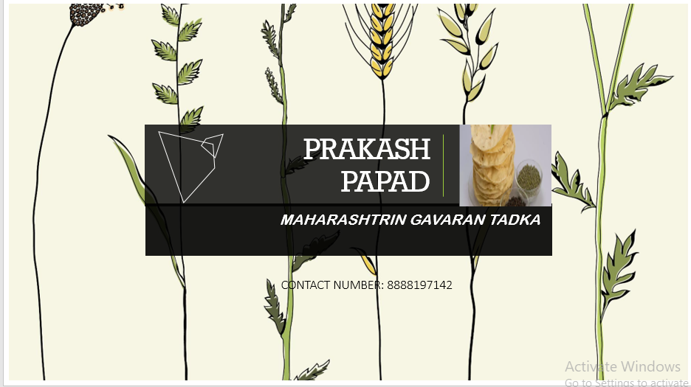

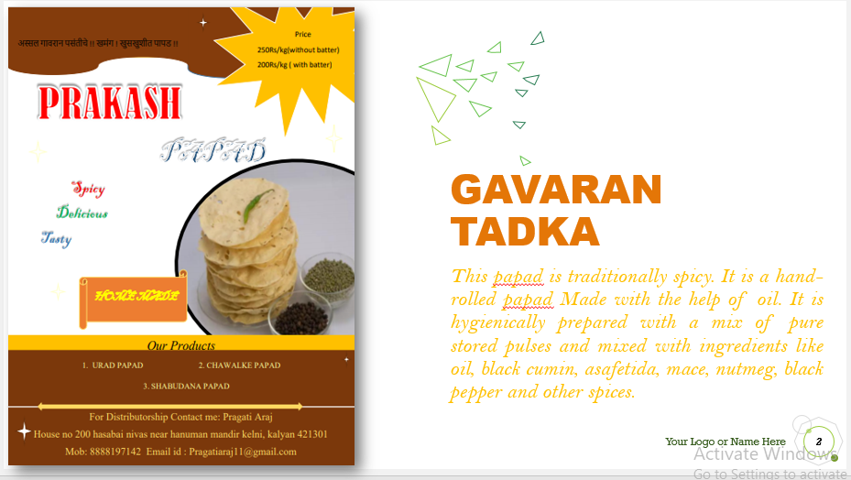

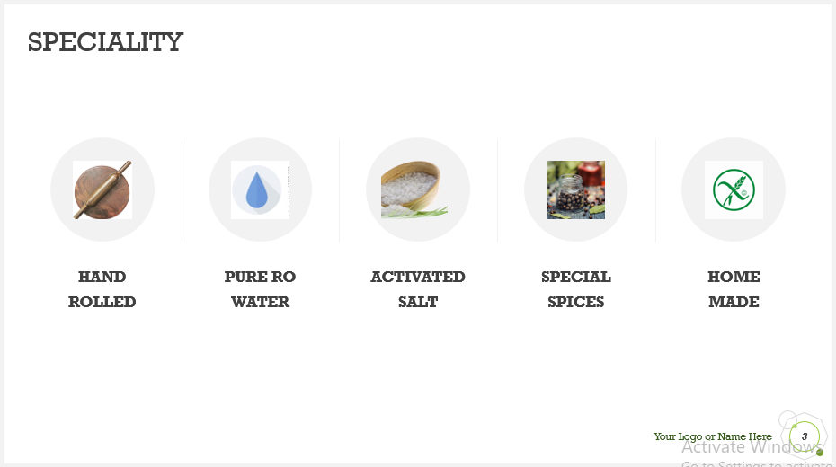

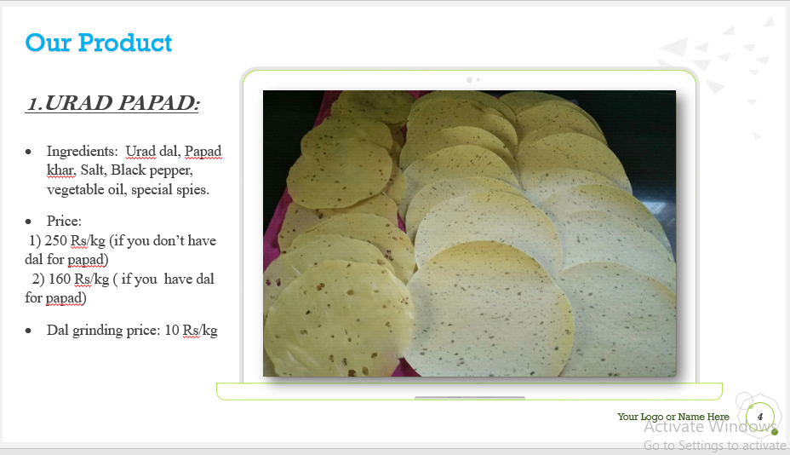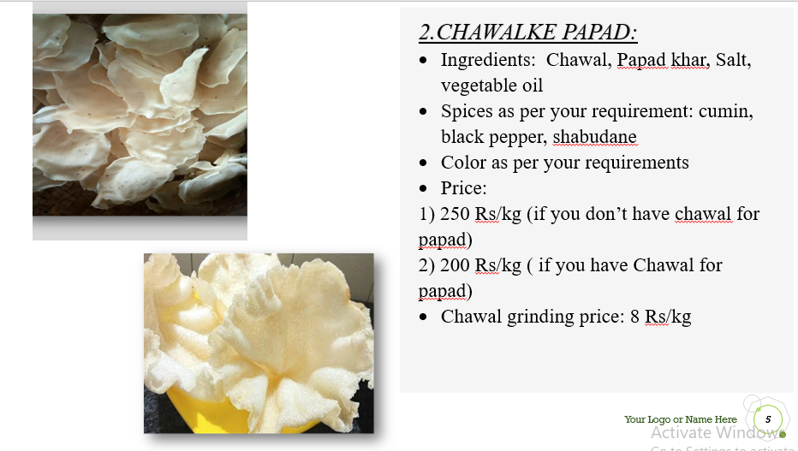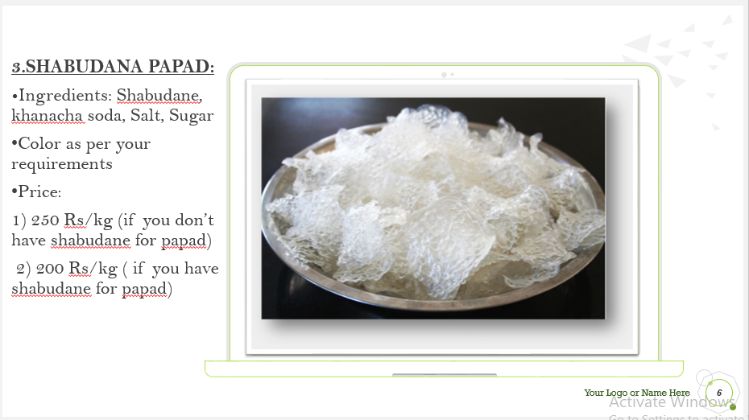

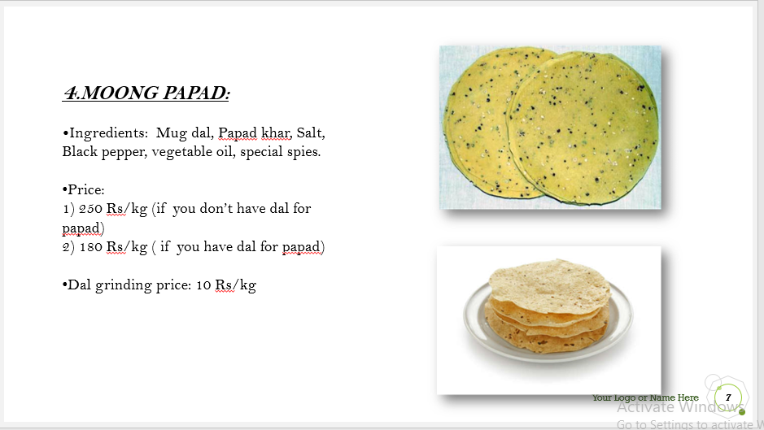

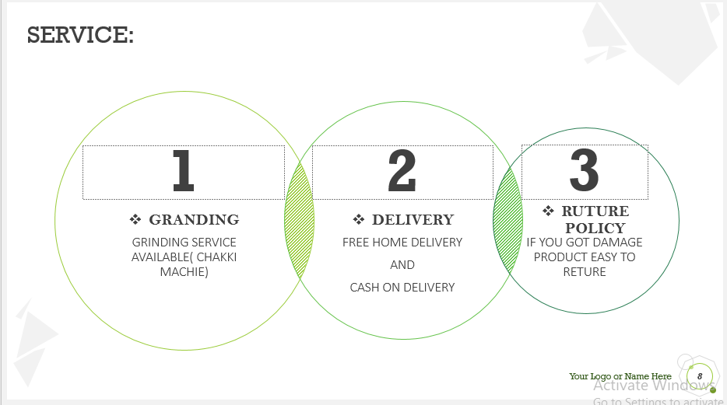

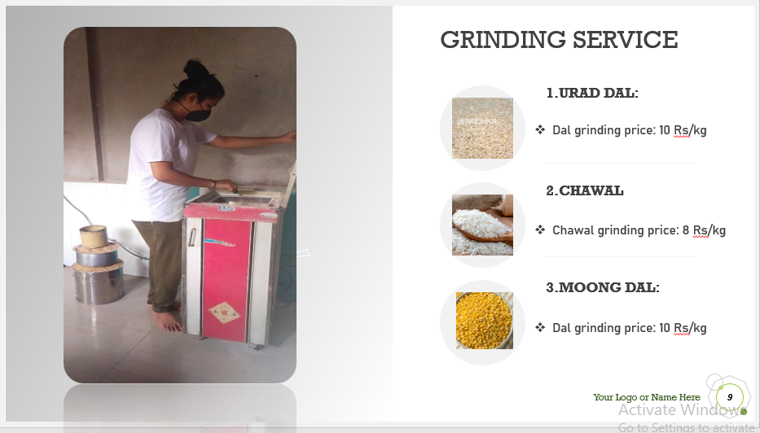

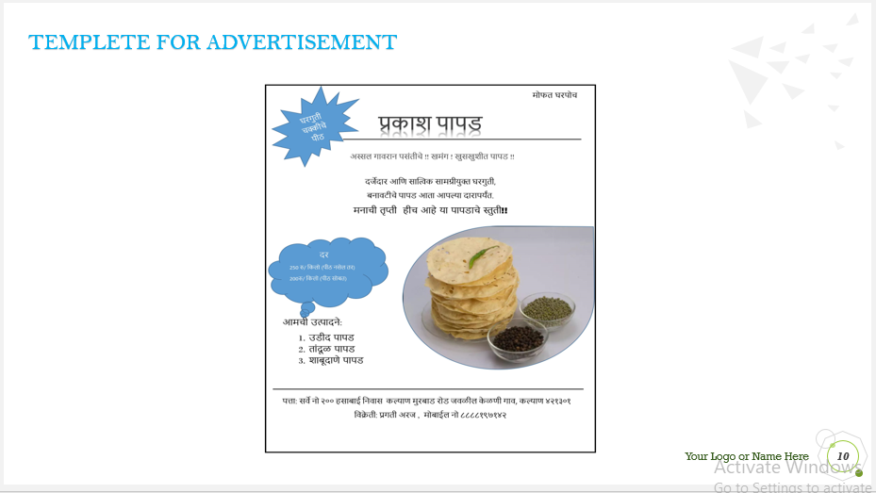

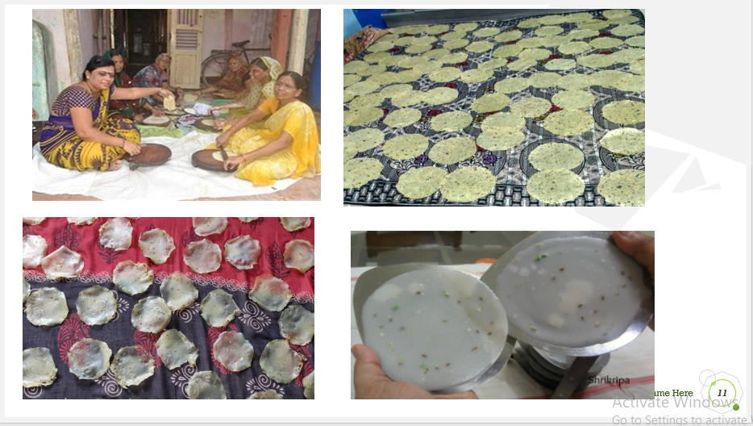

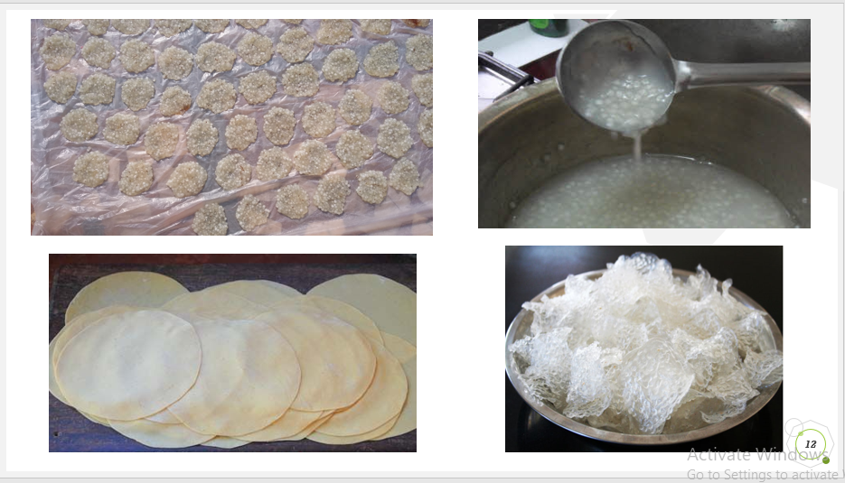

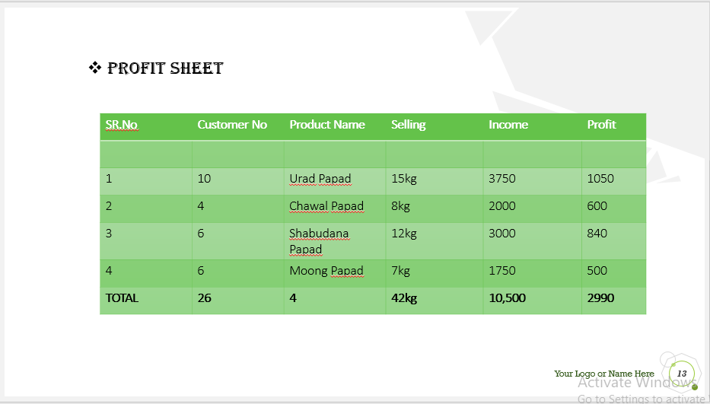



Conclusion

In this pandemic situation we all student and teacher took effort to become this webinar successful. We made planning for bazaar or umang event for that our guide Deshpande mam always encouraging to give the best for this webinar. Really on that all student gave their idea, support and time. Teacher arranged the google meeting for event. It that time I realized that if you can’t change the situation but you can change the way that you can do. This webinar helps us to improve our business skill and management skill. For making successful webinar we done many business plan, analyzing report it helps us in future to making our own business